Fry Sight Word Inventory
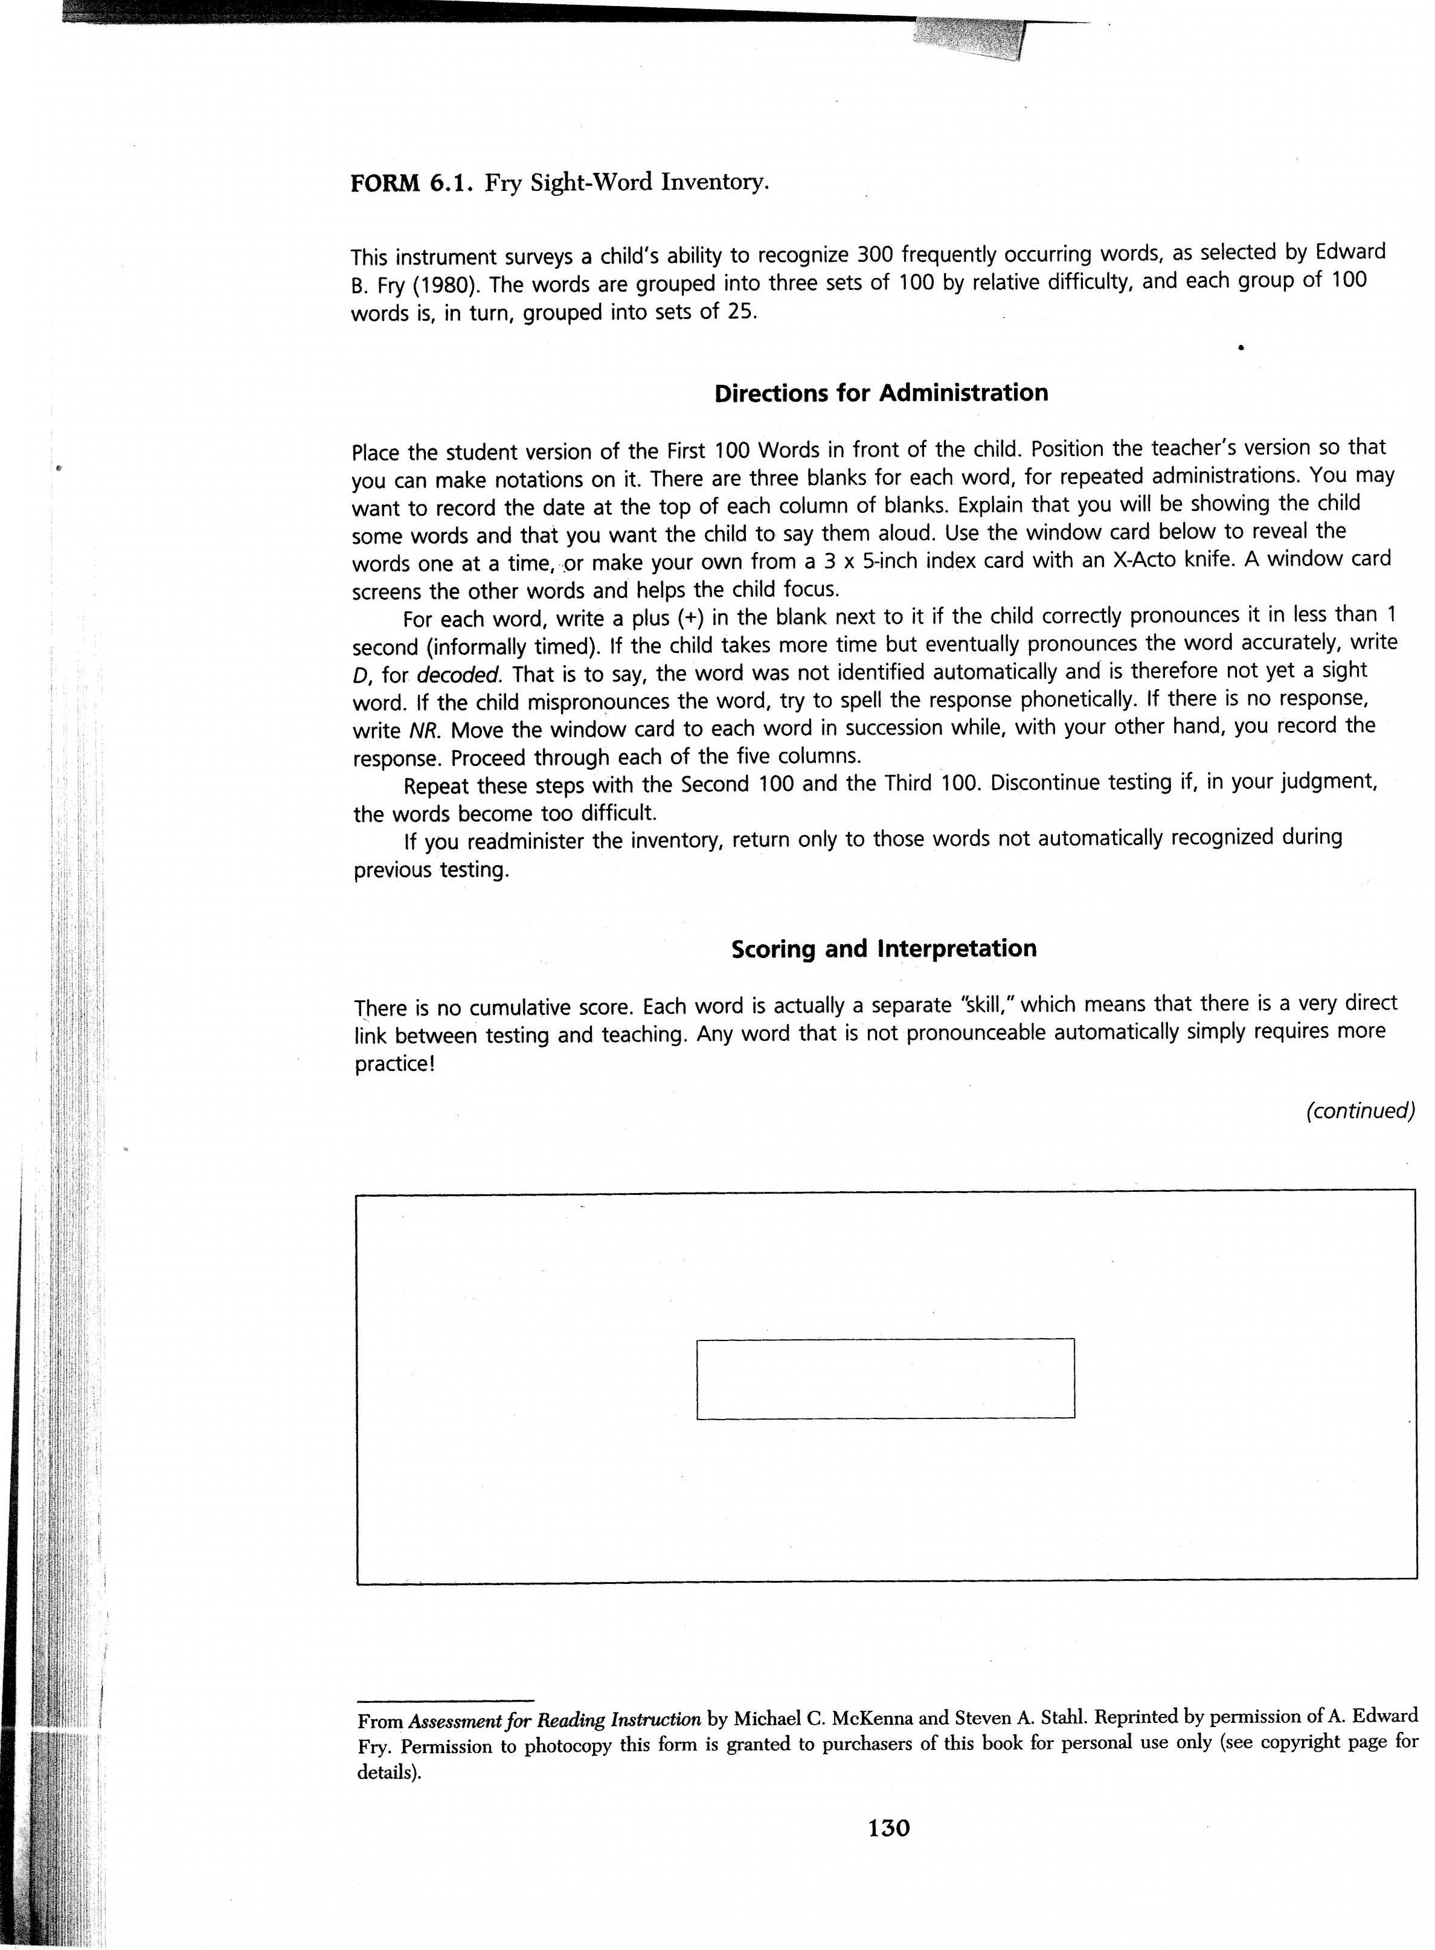
**These directions apply to the 400 and 500 lists also!

First 100 Words

the
of
and
a
to
in
is
you
that
it
he
was
for
on
are
as
with
his
they
I
at
be
this
have
from

or
one
had
by
word
but
not
what
all
were
we
when
your
can
said
there
use
an
each
which
she
do
how
their
if

will
up
other
about
out
many
then
them
these
so
some
her
would
make
like
him
into
time
has
look
two
more
write
go
see

number
no
way
could
people
my
than
first
water
been
call
who
oil
sit
now
find
long
down
day
did
get
come
made
may
part

Second 100 Words

over
new
sound
take
only
little
work
know
place
year
live
me
back
give
most
very
after
thing
our
just
name
good
sentence
man
think

say
great
where
help
through
much
before
line
right
too
mean
old
any
same
tell
boy
follow
came
went
show
also
around
form
three
small

set
put
end
does
another
well
large
must
big
even
such
because
turn
here
why
ask
want
men
read
need
land
different
home
us
move

try
kind
hand
picture
again
change
off
play
spell
air
away
animal
house
point
page
letter
mother
answer
found
study
still
learn
should
America
world

Third 100 Words

high
every
near
add
food
between
own
below
country
plant
last
school
father
keep
tree
never
start
city
earth
eye
light
thought
head
under
story

saw
left
don’t
few
while
along
might
close
something
seem
next
hard
open
example
begin
life
always
those
both
paper
together
got
group
often
run

important
until
children
side
feet
car
mile
night
walk
white
sea
began
grow
took
river
four
carry
state
once
book
hear
stop
without
second
late

miss
idea
enough
eat
face
watch
far
Indian
real
almost
let
above
girl
sometimes
mountain
cut
young
talk
soon
list
song
being
leave
family
it’s

Fourth 100 Words

body
music
color
stand
sun
questions
fish
area
mark
dog
horse
birds
problem
complete
room
knew
since
ever
piece
told
usually
didn’t
friends
easy
heard

order
red
door
sure
become
top
ship
across
today
during
short
better
best
however
low
hours
black
products
happened
whole
measure
remember
early
waves
reached

listen
wind
rock
space
covered
fast
several
hold
himself
toward
five
step
morning
passed
vowel
true
hundred
against
pattern
numeral
table
north
slowly
money
map

farm
pulled
draw
voice
seen
cold
cried
plan
notice
south
sing
war
ground
fall
king
town
I’ll
unit
figure
certain
field
travel
wood
fire
upon

Fifth 100 Words

done
English
road
halt
ten
fly
gave
box
finally
wait
correct
oh
quickly
person
became
shown
minutes
strong
verb
stars
front
feel
fact
inches
street

decided
contain
course
surface
produce
building
ocean
class
note
nothing
rest
carefully
scientists
inside
wheels
stay
green
known
island
week
less
machine
base
ago
stood

plane
system
behind
ran
round
boat
game
force
brought
understand
warm
common
bring
explain
dry
though
language
shape
deep
thousands
yes
clear
equation
yet
government

filled
heat
full
hot
check
object
am
rule
among
noun
power
cannot
able
six
size
dark
ball
material
special
heavy
fine
pair
circle
include
built

